Contents

1. The green transition as a pathway for a sustainable future 2
1.1 New political context and priorities 3
Competitiveness of the green transition 4
1.2 The green transition as response to global challenges 5
Tipping points: the need for accelerated actions 5
The costs of inaction 6
The effects of climate change on health 11
1.3 What people think about the green transition: the social perception of the EGD 14
1.4 Where we are: progress towards green ambitions 15
1.5 The green transition as a catalyser for achieving the Sustainable Development Goals 16

- Setting the scene: green transition as a pathway for a sustainable future

  - New political context and priorities
The EU’s current political agenda, framed by the Strategic Agenda 2024-2029 [1], underscores the central role of the green (and digital) transition in steering Europe towards sustainable development and economic resilience. This renewed focus is driven by the pressing need to respond to evolving global challenges, including geopolitical tensions, shifting economic power dynamics, and the accelerating impacts of climate change. Therefore, the objectives of the European Green Deal continue to be central to the EU’s strategic framework, integrating climate action with economic growth, ensuring that Europe remains at the forefront of green technology and innovation.
Indeed, the European Commission’s President has reaffirmed her commitment to the green transition, emphasising the need to stay the course on the goals set out in the European Green Deal, which remains a blueprint for fostering economic resilience, social cohesion, and global leadership. Since its launch in 2019, the European Green Deal (EGD) has made significant progress in driving the EU's transition to a low-carbon economy. The implementation of the green transition is however increasingly facing various new challenges. The EU grapples with rising geopolitical conflicts and unprecedented trade tensions, with slow economic growth and technological competition. Whilst the green transition supports the redefinition of the EU’s competitiveness and security agenda, the political, economic, social and regulatory frame in which it is analysed is shifting.
To this aim, aligning sustainability with competitiveness is essential for the EU’s strategic future, also in light of the new priorities set by the Commission, with its flagship initiatives of the Competitiveness Compass and the Clean Industrial Deal, which point towards strengthened competitiveness, decarbonisation, closing the innovation gap, reducing energy dependencies and increasing security. Achieving the green transition requires not only environmental progress but economic resilience—a balance necessary to meet rising global tensions and competition [2], [3], [4]. Addressing this challenge calls for a comprehensive approach that integrates sustainability into the EU’s economic framework. Therefore, for this evaluation the integration of sustainability and competitiveness serves as the guiding framework, drawing on evidence from key reports and policy documents that emphasize an adaptive, innovation-driven approach to the green transition.

The 2025 JRC report "Delivering the EU Green Deal - Progress towards targets" notes that while progress has been made in aligning policies with the EGD’s objectives, implementation gaps still persist. This work is an important piece of the puzzle in understanding where the EU stands, and underlines the need for enhanced coordination, targeted investment, and policy cohesion (see following section 1.4).

Building on these findings the present report aims to identify what is needed to bridge the remaining gaps and accelerate the progress. It takes a look at the challenges ahead and dives deeper into existing barriers to implementation. Furthermore, the report unveils potential enablers to foster progress towards the EU’s green transition goals and better assess the state of the green transition in the EU. The report also provides an integrated environmental assessment of a selection of EGD targets and ambitions (e.g., diet changes), able to inform measures needed to address the evolution of production and consumption patterns, by estimating their overall life cycle related impacts (see Chapter 3).

Recognising that combining sustainability with competitiveness is essential for the EU’s strategic future, this report provides a roadmap for aligning the objectives of the EGD with evolving economic and security conditions. It aims to contribute to the EU’s progress towards its climate neutrality goal while maintaining a competitive edge, building resilience and ensuring social fairness.

  - The green transition as response to global challenges
Climate change, environmental degradation, and social inequality are intertwined crises that demand a comprehensive response. The green transition is the necessary response and vital opportunity to these challenges, but it must be pursued in a way that balances environmental protection and climate action with social justice. Rather than being seen as a costly burden, the green transition can be a catalyst for EU competitiveness, driving innovation and growth while ensuring a sustainable and equitable future. This section explores the imperative of urgent action, highlighting the critical thresholds beyond which irreversible damage will occur, the health impacts of climate change, and the staggering "costs of inaction" for both the climate and biodiversity. By examining the interplay between negative and positive tipping points, we can unlock a new narrative for the green transition, one that harnesses its potential to transform the EU's economy and society for the better.

Tipping points: the need for accelerated actions
Global Tipping Points are critical thresholds, mostly related to temperature, at which small changes can lead to dramatic shifts in the state of fundamental Earth Systems such as land/water ecosystems, glaciers, atmospheric elements, and ocean currents (Tipping Systems). Increases in CO2 and its associated global warming are the major forces behind Tipping Points, but a growing number of co-drivers such as deforestation, ocean acidification, pollution, water eutrophication, albedo, extreme weather events, ecosystem fragmentation, overfishing, etc., are known to be pushing the Earth Tipping Systems into irreversible, self-sustained, destabilization processes that will lead to their eventual collapse.
The latest Global Tipping Point Report [5] identified more than 50 potential Tipping Systems. Empirical evidence suggests that at least up to 15 Tipping Systems are now actively responding to global warming [6], [7]. Six out of them have their expected Tipping Points close to 1.5 °C: Greenland Ice Sheet, Western Antarctic Ice Sheet, Coral Reef Systems, Boreal Permafrost, Barents Sea Ice, Labrador Sea-Subpolar Gyre Convection. Tipping Points for regional Coral Reefs are now feared unavoidably crossed for the Caribbean and its Mesoamerican Reefs, and the remaining Tipping Systems are seeing their temperature thresholds decrease year after year.
Global tipping points present substantial biophysical impacts that can affect Europe in various ways. From the melting of Arctic ice and the Greenland ice sheet to disruptions in the Atlantic Meridional Overturning Circulation (AMOC), boreal forest dieback, permafrost thaw and Mediterranean desertification, the continent faces numerous challenges. These impacts not only threaten Europe's natural environment but also its economic stability, public health, and social fabric. Addressing these challenges requires the understanding of the risks and impacts of Tipping Points to support the formulation of precautionary and anticipatory strategies, which can then lead to innovative adaptation strategies. One anticipatory strategy remains, however, the urgent commitment to reducing greenhouse gas emissions to avoid crossing these critical thresholds.
On the other side, positive tipping points can drive substantial progress towards sustainability. These are transformational milestones in societal change that become self-reinforcing and accelerated, and have the potential to catalyze shifts in behavior, norms, and practices that collectively drive progress towards a more sustainable future [8].
Several positive social tipping points have been identified whose achievement can reinforce Europe's green transition, including:
- Renewable Energy Adoption: The widespread adoption of renewable energy sources such as wind, solar, and hydro, driven by increased awareness of climate change and government policies like Germany's Energiewende.
- Sustainable Transportation: The preference for sustainable transportation, including electric vehicles, cycling, and public transportation, driven by government incentives and cultural changes like the normalization of cycling in cities like Copenhagen.
- Circular Economy Practices: The rise of the circular economy, which involves reducing waste, reusing materials, and recycling products, driven by consumer demand and initiatives like zero-waste stores and sustainable fashion movements.
- Youth Activism and Education: The emergence of youth-led climate activism, epitomized by movements like Fridays for Future, and the integration of sustainability into education curricula, which shapes societal norms and policies.
- Digitalization and Smart Technologies: The integration of digitalization and smart technologies in everyday life, which enhances resource management, reduces emissions, and fosters a culture of sustainability.
Leveraging these positive social tipping points is crucial to drive systemic change and accelerate the transition towards a more sustainable future. By harnessing the collective power of renewable energy adoption, sustainable transportation, circular economy practices, youth activism, and digitalization, Europe can drive the systemic change and achieve the green transition.

The costs of inaction
The "costs of inaction" refer to the economic, social, and environmental consequences of not taking measures to address climate change and environmental degradation. When assessing climate change and environmental policies, a comprehensive approach that accounts for both the costs and benefits of action and inaction is necessary. Such an approach allows for better informed decision-making, helps prioritize actions that minimize the risks and consequences of climate change, and can serve as a powerful motivator for individuals, organizations, and governments to take urgent and collective action to address the climate crisis and protect the environment. Moreover, considering the costs of inaction can also help to identify opportunities for cost savings and economic benefits associated with taking action.
Climate-related costs of inaction
To better understand costs of inaction, the pan-European climate risk assessment PESETA [9] is published regularly by the JRC, covering a wide range of climate impact categories. The methodology integrates a combination of state-of-the-art process-based and empirical models that translate high-resolution projections of climate conditions into biophysical and economic impacts. The cost of inaction refers to the simulated climate damages without any policy action, i.e. without adaptation or mitigation policies.
This section identifies projected damages under a 3°C global warming scenario as the “cost of inaction”. For few impact areas, 4°C scenario damages are also reported. Economic damage estimates consist of climate impacts that would occur by the year 2100. The JRC study provides results regarding climate impacts on people, the environment and the economy, with both biophysical and economic metrics. The consistent results summarised below refer to the eleven JRC PESETA IV project impact areas [10], [11] (human mortality from heat and cold waves, windstorms, water resources, droughts, river flooding, coastal flooding, wildfires, habitat loss, forest ecosystems, agriculture and energy supply) and the follow-up studies (e.g. labour productivity).
Preliminary results of the JRC PESETA V project are presented in figure 1, representing the additional economic costs (as a percentage of GDP) for the 2°C scenario by 2050 for the following impact areas: coastal floods, droughts, labour productivity, river floods, transport infrastructure, windstorms and energy demand. The burden of climate change shows a clear north-south divide, with southern regions in Europe impacted relatively more and, particularly, southern-eastern regions. That spatial pattern is due mainly to consequent changes in high-end temperatures and the spatial and temporal availability of water.
Figure 1. Additional economic costs for 2°C scenario by 2050, as a share of GDP (coastal floods, droughts, labour productivity, river floods, transport infrastructure, windstorms and energy demand)
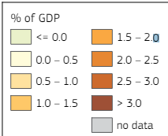
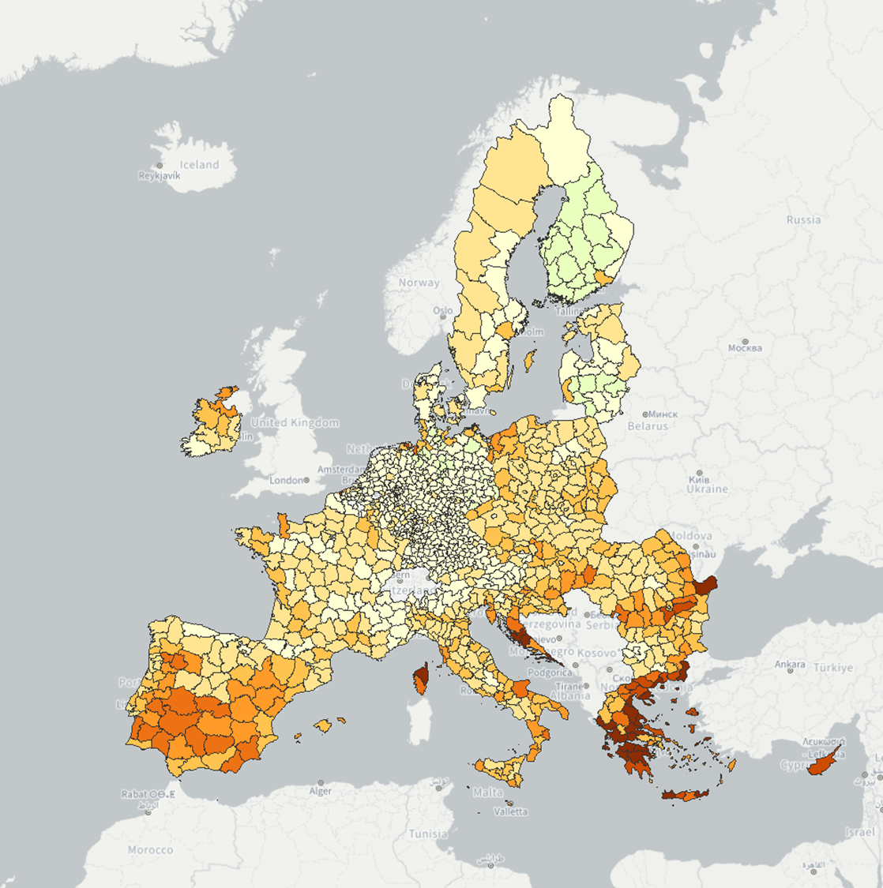
Source: 9th Cohesion Report, European Commission (2024).

The main results for the 3°C temperature degree scenario follow.
Climate impacts on people
- Temperature-related deaths could increase by around 55,000 additional deaths by 2100, driven by rising heat-related deaths and an ageing population. Climate change is also expected to widen disparities in regional mortality, particularly impacting southern regions of Europe as a result of a marked increase in heat-related deaths.
- Around 450,000 people would be exposed to river flooding each year, or nearly three times the number at present.
- 1.4 million people would be exposed per year to coastal inundation compared to around 70,000 at present, i.e. a 20-fold increase.
- An additional 15 million Europeans living in the proximity of wildland would be exposed to high-to extreme fire danger for at least 10 days/year.
- Water resources availability would drop by up to 40% in Southern regions of Europe and droughts would happen more frequent in most of Southern and Western Europe.
Climate impacts on the environment
- The Alpine tundra domain would contract by 84% and practically disappear in the Pyrenees. The natural climatic tree line would shift vertically up by up to 8 m/year.
- Ecological domains would shift northwards, resulting in severe changes of the prevailing domains in southern Europe and Boreal areas and the encroachment of the Tropical domain in Europe.
- Wildfire and pest outbreaks will become more frequent and severe, increasing biomass loss and additional carbon release (and warming).
Climate impacts on the economy
- River flood losses would rise 6-fold in magnitude, reaching 43 €billion/year with 3°C.
- Coastal flood losses would grow by two orders of magnitude and climb to 200 €billion/year, from 1 €billion today.
- Drought losses would increase to nearly 41 €billion/year with 3°C warming (60 €billion/year with 4°C warming), compared to around 8 €billion/year at present.
- Water scarcity and drought would increasingly affect agriculture, energy production and water supply in regions that already suffer from water stress.
- Labour productivity could be 0.7% lower in Europe, compared to nowadays.
- There would be a regional redistribution of tourism demand within Europe, with also relative reductions in summer and increases in the shoulder and winter seasons.

Key impacts not considered in the JRC PESETA assessment include those related to the irreversible damage to nature and species losses, aquatic and marine ecosystems, water- and vector-borne diseases, air quality, displacement of people, conflicts and security, and the potentially daunting consequences of passing climate tipping points. The extent of extreme events are also not fully captured, such as those of heat stress on crop yields and droughts on energy production. Cascading climate effects across sectors and from the rest of the world are also poorly understood.
This implies that the biophysical and economic impacts reported in PESETA represent just a lower bound of the cost of inaction for Europe. Furthermore, the assessment does not consider other fundamental cost categories indirectly associated to climate inaction: high energy supply vulnerability (notably higher energy import bill and the associated potentially large macroeconomic costs in terms of economic growth, inflation and employment), higher air pollution and security issues (e.g. migration).

Biodiversity related cost of inaction
On top of the cost associated to a delay in preparing the EU to climate change, there is a considerable cost of inaction when it comes to protect and restore biodiversity. In fact, nature provides benefits to people and economy through ‘ecosystem services’ – such as the pollination of crops, protection of coasts from flooding and erosion, supply of fresh water, wood production, marine fisheries and carbon sink and storage. As the natural assets (such as forests, wetlands, coral reefs and seas) that provide these services decline, the economic burden on societies increases (including GDP, trade, and production and commodity prices).
Financial resource to protect and restore the planet’s more fragile natural resources currently amounts to $166 billion per year globally (for comparison, less than one-sixth of the annual investment in the greening of the energy system [12]), but it will need to increase to about $1 trillion globally by 2030 [13]. While this is a sizable sum, it pales in comparison to the anticipated economic cost of biodiversity loss by the end of the decade. Even by the World Bank’s conservative estimates, the deterioration of natural processes like wild pollination and resources like marine fisheries could see global GDP come in $2.7 trillion a year lower than projected levels by 2030.
Similarly, a detailed report [14] by WWF concluded that, “unless we reverse nature loss, trillions of dollars” (globally) “will be wiped off the world’s economies, industries will be disrupted and the lives of millions will be affected”.
The study calculated the reduction of supply of six ecosystem services in a ‘Business-as-Usual’ scenario, which would lead to an annual loss of US$ 479. Over the period between 2011 and 2050, the total cumulative loss would be US$ 9.87 trillion (3% discount rate). These figures should be considered highly conservative and should not be considered an assessment of the total costs of nature’s loss, since the current model only considers six of the many ecosystem services provided by nature (those for which there is enough evidence to quantify). Nor does it account for the potential effects of ‘tipping points’.
As a consequence of a decrease of ecosystem condition and hence in ecosystem services, the world’s agricultural sectors will be hardest hit by the loss of nature’s benefits, and the prices of several basic commodities will increase.
In Europe, biodiversity is in rapid decline and the economic picture is aligned with the global one. Economists estimate the loss of biodiversity in Europe costs the EU around 3% of GDP per year and global biodiversity loss is valued at around €50bn. Crop pollination alone is worth more than €14bn annually, while wetlands provide an estimated €6bln in ecosystem services each year [15]. The INCA project (implemented at JRC) delivered an estimate of the monetary value of ESS in Europe [16].
Acting to restore and conserve our natural environment is clearly a worthwhile investment and should be thought of as a “cost.” Failure to act would, however, come with a significant price tag for the economy and society. For example, managing the Natura 2000 network requires an investment of around €5.8bn per year, but it generates €200bn to €300bn per year in economic benefits, according to European Commission figures.
Ensuring more effective implementation of EU Nature Directives at national and regional level, and placing greater importance on the value of our natural capital, as aimed in the EU Regulation on Nature Restoration, would have considerable benefits for biodiversity, sustainable economic development and Europe’s prosperity.
To this goal, the Biodiversity Finance Factbook [12] identifies six overriding tasks that governments, companies, and financial institutions must address:
- Back initiatives to collect and share biodiversity data and harmonize metrics and frameworks.
- Integrate biodiversity into planning, operations and reporting.
- Reform environmentally-harmful subsidies and boost biodiversity support.
- Develop replicable business models and use concessional funding to address the dearth of bankable biodiversity projects.
- Improve the environmental integrity of offsets and other mechanisms.
- Promote industry and local community buy-in.

The effects of climate change on health
Climate change is a major stress to the environment, hence on the connected organisms it hosts such as microorganisms, plants, animals, and humans. Consequences of climate change are thus global, multifaceted and far-reaching. It is modifying the current behavior of living organisms and pushing them beyond their physiological limits, with major and long-lasting impacts on all living organisms on the planet. Already in 2015, WHO, stated that “Climate change is the greatest threat to global health in the 21st century”. Later in July 2023, for the first time in history, climate crisis and related extreme weather events were declared a public health emergency by the WHO Regional Office for Europe. In fact, accordingly to the World Economic Forum (WEF), by 2050 climate change is likely to cause an additional 14.5 million deaths and $12.5 trillion in economic losses worldwide including $1.1 trillion in extra costs to healthcare systems [17], [18]. In tackling the causes and mitigating the consequences of climate change, it is central to adopt an integrative strategy, as environment, animals and humans are tightly connected (i.e. the One Health approach).
Effects of climate change on health are numerous (see Figure 1), and include direct and indirect impacts.

Figure 1. Scheme summarizing the different impacts of climate change on health
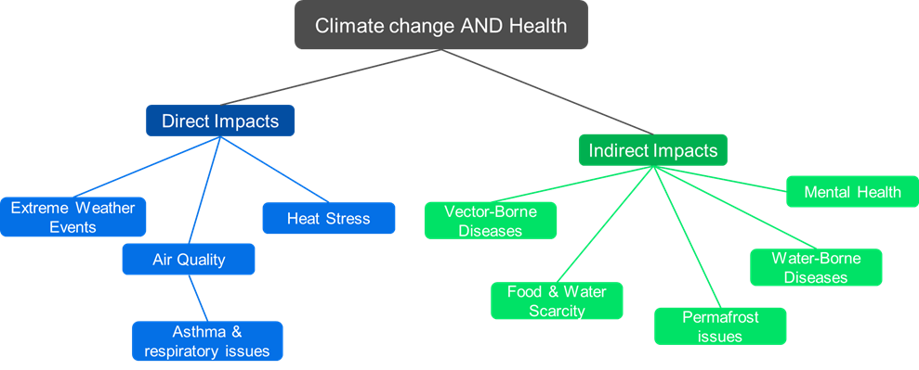
Source: Authors’ elaboration.

Direct impacts
- Heat stress: As temperatures globally rise, heat stress becomes a major concern, particularly for vulnerable populations such as the elderly, young children, and those with pre-existing medical conditions. Heat stress can lead to heat exhaustion, heat stroke, and even death.
  - In Europe, heat waves are estimated to have caused between 77,000-129,000 excess deaths between 1980 and 2020 [19]. Only in the summer of 2003, between 40,000 and 70,000 excesses of heat-related deaths occurred in Europe [20], [21].
  - A study published in The Lancet found that heat-related mortality in Europe could increase by 20-30% by 2050 if greenhouse gas emissions continue to rise [22].
- Extreme weather events: Climate-related disasters, such as hurricanes, wildfires, and floods, typically result in displacement, physical injuries, and loss of lives. These events can also have long-term effects on mental health, including anxiety, depression, and post-traumatic stress disorder (PTSD).
  - Floods are the highest risk of acute climate-induced mortality, potentially accounting for 8.5 million deaths by 2050 worldwide [17], [18].
  - Droughts, the second cause, have an estimated 3.2 million deaths as consequence of reduced access to food and water security and the increase of dust concentration, therefore also increasing respiratory diseases [17].
- Air quality: Poor air quality (pollutants such as PM_{2.5}, PM₁₀, O₃, NO₂, SO₂) can exacerbate respiratory conditions like asthma and chronic obstructive pulmonary disease (COPD), but also cardiovascular disease, particularly for those with pre-existing conditions and lung cancer.
  - In Europe, each year around 300 000 people die prematurely due to air pollution [23]. By 2050, levels of SO₂ and NO₂, are expected to rise 90% and 50%, respectively [24].
  - In the EU, the average life expectancy is estimated to be reduced by 8.6 months due to the PM_{2.5} exposure [21].
- Asthma and respiratory issues: Asthma affects over 30 million people in Europe. Since climate change and higher CO₂ levels are linked to increased pollen production [21], it can exacerbate allergies and respiratory issues like asthma. The above-mentioned pollutants such as PM_{2.5}, PM₁₀, O₃, NO₂, SO₂ have been shown to have an inflammatory effect on the airways of susceptible subjects increasing permeability and therefore facilitating the interaction with cells of the immune system [21].
  - Studies estimate that sensitization to ragweed will increase from 33 to 77 million people, by 2041–2060 in Europe [25].

Indirect impacts
- Food and water scarcity: Changes in temperature and precipitation patterns can lead to crop failures, reduced food availability, leading to food insecurity, as well as decreased water quality. This can result in malnutrition and micronutrient deficiencies, particularly for vulnerable populations.
  - The increase of heatwaves and droughts events in 2021 was associated with 127 million more people experiencing moderate or severe food insecurity than in the period 1981–2010, with the consequent risk of malnutrition and potentially irreversible health effects [26].
- Vector-borne diseases: Climate change is altering the distribution and prevalence of disease vectors like mosquitoes, ticks, and fleas. This can lead to the emergence or re-emergence of pathogens, and increased risk of diseases like malaria, dengue fever, and Lyme disease, to name just a few.
  - Accordingly to the ECDC, the number of locally acquired dengue cases has steadily increases, from 71 in the period 2010-2021, to 71 cases just in 2022 alone and 130 cases in 2023. The number of outbreaks is also increasing [27].
  - By 2050, an additional 500 million people may be at risk of exposure to vector-borne diseases (i.e., malaria, dengue and Zika) [28]. Just in Europe, the risk of malaria transmission could increase by 10-20% by 2050 if climate change continues [17].
- Water-borne diseases: Changes in precipitation patterns, sea-level rise, and increased flooding can contaminate water sources, spreading water-borne diseases like cholera and diarrhea.
- Antimicrobial Resistance (AMR):as declared by WHO, AMR is one of the top ten global public health threats facing humanity that claims about 700,000 lives per year and it is estimated to cost between $300 billion to $1 trillion per year by 2050 [29]. Despite the main reason for AMR is the excessive and inappropriate use of antibiotics, climate change can exacerbate it since:
a) bacteria growth and reproduction are facilitated by temperatures above 30° C [30];
b) flooding can cause wastewater and sewage, the major vehicles of AMR in surface waters, to overwhelm treatment plants and contaminate surrounding areas [31], [32] (AMR genes were reported also deep in the oceans [33]);
c) the biodiversity loss diminishes the richness of plant species that might hold the key to new treatments against resistant bacteria [31], [33].
- Mental health: Climate change can have a profound impact on mental health, from anxiety and depression to post-traumatic stress disorder (PTSD) and suicidal ideation. The stress of living in a rapidly changing environment can be overwhelming, particularly for those who have experienced traumatic events [34]. These effects pose threats particularly for vulnerable groups with limited coping capacities (adolescents, young adults, elders) and those with pre-existing mental disorders.
  - According to WEF, the mental health effects, particularly PTSD, of climate change events are estimated on $275 billion and 58 million DALYs worldwide [17]. Generalized anxiety, associated with droughts, is projected to cost $198 billion to the health system and impact 176 million DALYs worldwide [17].
  - Another study indicates that for every 1 °C increase in temperature there is an associated 2.2% increase in mental health-related mortality [35].
  - One year after a flood in England, 36% of the regional population suffered from PTSD, around a quarter suffered from anxiety disorders and a fifth from depression [36].
  - In the case of the recent devastating flood of Valencia region (Spain) it is estimated that 20-25% of the population of the destroyed ground zero will suffer different forms of post-traumatic stress. In addition, the post-traumatic stress raised to 70-80 % among those that have seen death-bodies, those feeling intense guilt for having survived or not been able to help more, and those previously in treatment [37].
- Permafrost issues: thawing of permafrost can also impact human health through the following main pathways [38]:
  - Release of trace elements (e.g. metal contaminants) and major ions, previously stored in the permafrost, into water sources with the subsequent health consequences (i.e., cancers, developmental and reproductive disorders, cardiovascular and skeletal diseases, and neurotoxicity).
  - Release of previously contained pathogens, including antibiotic-resistant bacteria and unknown viruses. The risk of preserved pathogens being active after thawing is low, yet the consequences of their release are difficult to predict [39].
  - Release of chemical and radioactive waste stored in industrial sites located on degrading permafrost.

Globally, climate change is likely to exacerbate existing health inequities by affecting the social determinants of health, such as access to clean water, sanitation, and healthcare. Economic losses, and decreased productivity will obviously affect agriculture, food prices, and availability, thus challenging global food systems that will be more likely to be disrupted. This may lead to social instabilities, and in some countries, to malnutrition and food insecurity. Consequently, more migration and displacement are expected. This, in turn, can lead to more social, economic, and health problems, including higher stress levels among populations of Member States, increased (re)emergence and circulation of pathogens, higher vulnerability to disease, while society at large is expected to exhibit a decreased access to healthcare.

What people think: social perception of the EGD
Public sentiment plays a critical role in shaping the success of the green transition: to understand the evolving perceptions of the EGD transformative agenda, the JRC carried out an analysis of 582,156 Twitter/X posts from January 2020 to March 2024. The study uncovers clear patterns in how different stakeholders engage with various stages of the EGD's implementation (cit).
Public perception of the EGD has evolved significantly through distinct implementation phases, shaped by both policy developments across multiple sectors and external events. Analysis reveals that while general support for environmental and economic transformation remains strong, specific policy measures often face resistance when their immediate socio-economic impacts become apparent. The predominance of neutral sentiment (62%) in public discourse, compared to positive (28%) and negative (10%) reactions, indicates a crucial window of opportunity for policy communication and stakeholder engagement.
Temporal trends reveal four distinct phases in public perception. During the announcement phase (2020), cautious optimism prevailed, with positive sentiment reaching the 29% following the launch of the European Climate Law and key strategies such as Farm to Fork and Biodiversity. In the delivering phase (2020–2022), positive sentiment climbed further to 32%, bolstered by comprehensive packages like "Fit for 55", which demonstrated the impact of concrete, well-communicated policies. However, the acceleration phase (2022–2023) exposed vulnerabilities, with geopolitical events like the Russian invasion of Ukraine, shifting discourse. Negative sentiment rose to 18%, driven by energy security concerns and uncertainties surrounding systemic transitions. Most recently, the adoption phase (2023–2024) underscored progress as initiatives like COP28 elevated positive sentiment to 33%, even if sectoral disruptions, including the farmers' protests in early 2024 drove negative sentiment spikes up to 22%.
Thematic analysis underscores specific drivers of public sentiment. Positive sentiment often aligns with policies demonstrating tangible environmental and health benefits, such as improved air quality or biodiversity restoration, and those fostering economic opportunities through renewable energy and green innovation, notably under initiatives like REPowerEU. In contrast, negative sentiment tends to focus on perceived costs of economic transition, concerns in the agricultural sector regarding pesticide regulations, and immediate consumer impacts associated with product lifecycle and repair policies.
A notable divergence between institutional and public sentiment highlights a communication gap. EU-affiliated accounts demonstrate consistently higher positive sentiment (36%) than non-EU accounts (28%), suggesting that public messaging often fails to resonate with broader audiences. Policies that lack visible implementation pathways or adequate support mechanisms provoke heightened scepticism, with negative responses increasing.
The findings underscore the need for transparent, inclusive, and adaptive communication strategies to maintain public trust and engagement. The successful implementation of the green transition depends on maintaining and building public support while effectively managing inevitable transition challenges. The data clearly shows that public acceptance hinges not on the ultimate goals of the transformation agenda, but on how the transition pathway is managed and communicated. With 62% of sentiment remaining neutral, there exists a significant opportunity to build stronger support through targeted engagement strategies that address specific stakeholder concerns while maintaining focus on the EGD's transformative vision.
By emphasizing the immediate and localized benefits of EGD policies while addressing sector-specific concerns, policymakers can bridge existing gaps and foster wider acceptance. The integration of diverse stakeholder feedback and continuous sentiment monitoring will ensure that the ambitious goals of the Green Deal and the new Clean Industrial Deal align with public expectations, enabling a smoother and more inclusive green transition.

  - A macro-economic picture through main indicators
The EGD aims to transform the EU into a modern, resource-efficient, and competitive economy, ensuring no net emissions of greenhouse gases by 2050. To achieve this ambitious target, it's essential to provide the macroeconomic context across different sectors and understand trend with the help of key indicators. The analysis is based on datasets and national accounts provided by Eurostat, with a detailed breakdown of macroeconomic variables across time in EU27-2020 aggregate. This sub-section extends the broad analysis proposed in the Statistics for the European Green Deal (EGD).
Table 1. Quantification (shares and absolute numbers) of main indicators (GVA, jobs, emissions, investments) by NACE Rev. 2 macro-sectors, for EU27, 2022.
 | GVA |  | Employment |  | GHG emissions |  | Investments
 | % share | million EUR | % share | 1000 persons | % share | Ktonnes CO2 eq | % share | million EUR
Industry | 15% | 2,126,939 | 12% | 25,361 | 24% | 687,557 | 27% | 883,143
Energy & Mining | 3% | 466,939 | 1% | 1,647 | 28% | 800,484 | 0% | 1,532
Trade | 11% | 1,643,695 | 14% | 29,871 | 3% | 96,136 | 5% | 171,565
Transport & Storage | 5% | 720,910 | 5% | 11,254 | 15% | 433,504 | 1% | 23,186
Building/renovating | 5% | 774,334 | 7% | 14,404 | 2% | 51,256 | 39% | 1,310,617
Services | 56% | 8,035,650 | 55% | 119,105 | 11% | 308,644 | 28% | 922,714
Food system | 4% | 535,432 | 6% | 13,411 | 18% | 519,711 | 0% | 7,501
Source: Authors’ compilation, based on ESTAT statistics from SUT 2022, “Air emissions accounts by NACE Rev. 2 activity” [env_ac_ainah_r2] and Total Employment Domestic concept by activity [nama_10_a64_e].

Table 1 shows key indicators by economic sectors grouped according to the following macro-categories:
  - Industry, encompassing all manufacturing activities excluding food processing.
  - Energy and mining, including the extraction and production of energy resources and minerals.
  - Trade, including wholesale and retail trade activities.
  - Transport and storage, including transportation services and storage facilities.
  - Building/renovating, including construction activities.
  - Services, that includes all other service activities.
  - Food system (Agri+Food), including agricultural activities, food processing, and related services.
The table quantifies the distribution of key indicators— GVA, jobs, emissions, and investments—across the NACE Rev.2 macro-sectors for the EU27 in 2022. It presents both the relative shares and absolute values of these indicators, providing a comprehensive view of the economic and environmental metrics of these sectors.
The GVA column reflects the economic output generated by the macro-sectors, illustrating their contribution to the EU economy. The Industry sector is the largest contributor to GVA, with a 15% share, amounting to €2,126,939 million. Following it, the Trade sector contributes 11% (€1,643,695 million), and the Building/Renovating sector adds 5% (€774,334 million).
In terms of employment, the table provides insights into the job distribution across macro-sectors. The Trade sector employs the most people, accounting for 14% (29,871 thousand persons). This is closely followed by the Industry sector at 12% (25,361 thousand persons). Other significant contributors include the Building/Renovating sector (7%, 14,404 thousand persons) and the Food System (6%, 13,411 thousand persons).
The emissions data highlights the environmental impact of various sectors. The Energy and Mining sector is the largest contributor to greenhouse gas emissions, accounting for 28% (800,484 KtCO₂eq). The Industry sector follows with 24% (687,557 Kt), while the Transport sector contributes 15% (433,504 Kt). In this regard, it is important to note that these figures account only for emissions from economic activities, excluding those related to household heating, cooling, transportation, and other emissions derived from their consumption. In contrast, the Food System contributes 18% of GHG emissions (519,711 Kt), despite its smaller share in GVA and employment, highlighting its significant environmental impact. On the other hand, investment figures are heavily concentrated in the Building/Renovating sector, accounting for 39% (€1,310,617 million). The Industry sector is the second largest in investment terms, with 27% (€883,143 million), while the remaining sectors contribute 28% (€922,714 million).

  - Where we are: progress towards green ambitions
In January 2025, the JRC published a comprehensive assessment of the implementation status and trends of policy targets across all domains of the EU Green Deal [40]. The analysis examined 154 quantifiable targets (binding and non-binding) from 44 key policy documents. As of mid-2024, 32 targets (21%) are “on track” and 64 targets (41%) require accelerated progress. Furthermore, 15 targets (10%) show no progress or regression and 43 targets (28%) lack sufficient data. The overall results are summarised in the infographic below. Progress is mixed, partly because many Green Deal legislative initiatives, such as the Nature Restoration Law, were only recently adopted and have yet to be implemented. Others are still under discussion or require long lead times before delivering significant results. Nevertheless, tracking progress is crucial to identifying where further action is needed to achieve the green transition.
Climate change mitigation efforts must be intensified as current reductions in sectors covered by the Effort Sharing Regulation and the LULUCF regulation are falling short. Accelerated action is especially critical in agriculture and carbon removal strategies. Methane emissions also require intensified abatement efforts. Despite a 32.5% decrease in EU GHG net emissions from 1990 to 2022, the pace of reduction from 2020 to 2030 must accelerate compared to previous decades.
The transition to clean energy should also be accelerated, with a focus on increasing the share of renewable energy sources. This requires substantial investments in renewable energy infrastructure, scaling up renewable hydrogen production, and strengthening power grids. To support this shift, it is crucial to accelerate the adoption of renewable hydrogen in industry and transport, along with developing dedicated infrastructure and an efficient hydrogen market. Additionally, current trends in energy consumption and energy efficiency must be reversed.
Conversely, the EU is progressing to meet its ambitions in circular economy, where about 30% of set targets are on track. However, trends must be reversed in the circular material use rate, and urgent acceleration is needed in recycling and preparation for reuse of waste, as most Member States are at risk of missing these 2025 targets. Initiatives must therefore prioritise waste reduction and material recovery, while addressing challenges related to data availability and the adoption of circular practices.
In sustainable mobility, decarbonisation of road transport requires a robust infrastructure for alternative fuels, with significant acceleration in deploying renewable hydrogen and electric charging stations. Advanced biofuels, biogas and renewable fuels of non-biological origin (RFNBOs) will be vital for decarbonising hard-to-electrify sectors like aviation and maritime transport. While urban transport is moving towards electrification, more rapid reductions in CO2 emissions from heavy-duty vehicles are still needed.
In the food system, trends need to be reversed in dietary patterns and health outcomes, employment quality, food affordability, consumption footprint, energy consumption, and waste generation. It is also essential to address challenges such as reducing greenhouse gas emissions, promoting sustainable agriculture practices, and reducing food waste.
The biodiversity thematic area presents particular challenges: 45% of the targets cannot currently be evaluated due to the lack of defined parameters and indicators for comprehensive biodiversity monitoring. In general, biodiversity and ecosystem restoration efforts should be accelerated, accompanied by improved data collection and monitoring to better assess progress towards targets. Progress has been made towards zero pollution in the areas of air pollution, chemical pesticides, and antimicrobial sales However, challenges remain in the areas of noise pollution, water quality, waste generation and emerging concerns such as microplastics.
The infographic in the next page provides a synthesis of the progress made towards the EGD targets, as described in detail in the JRC study [40]. For every thematic area, all the policy targets are listed, showing with colours their level of implementation (“green” on track, “yellow” acceleration needed, “red” stagnant or regressing, “grey” no enough data available).
This preliminary assessment of progress on EGD targets serves as a gauge of the complexity of the systemic transformation necessary for the success of the green transition. The “distance to target” analysis served as a basis for this current new report, which, capitalising on the findings of the first study, dives deeper into the barriers to implementation and into potential enablers across the different thematic areas, to gain a better understanding of the state of the green transition in the EU.

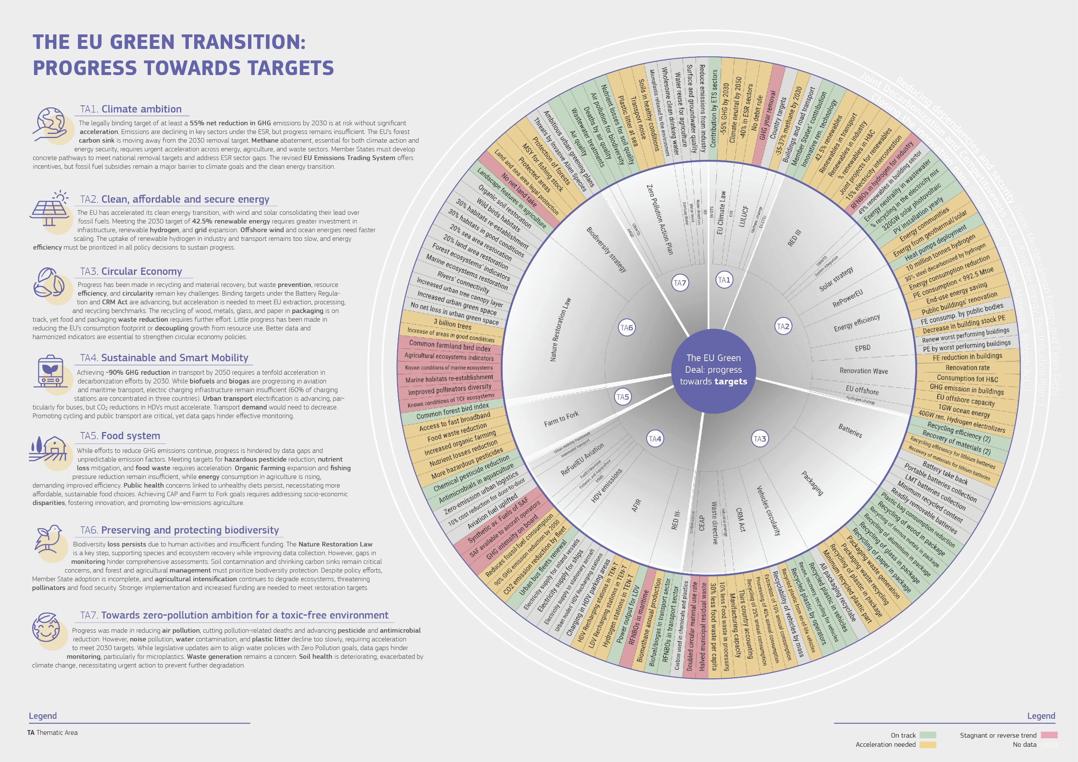
  - The green transition as a catalyser for achieving the Sustainable Development Goals
The EU green transition shares common ambitions with the UN 2030 Agenda and its Sustainable Development Goals (SDGs), starting from the urgent need to take action against climate change and its impacts, biodiversity loss and environmental degradation. The first EU Voluntary Review on the implementation of the 2030 Agenda for Sustainable Development showed how major policies like the EGD are at the heart of SDGs and an integral part of the Commission’s strategy to implement the 2030 Agenda [41] : (cite EUVR 2023, EGD Comm, 2019; SWD 2020, SDSN, 2022). The JRC assessment of progress towards EGD targets ([40], confirmed such strong connectionand linkages especially with SDG 13 (climate action), SDG 7 (affordable and clean energy), SDG 12 (responsible production and consumption), SDG 15 (life on land), and SDG 9 (industry, innovation and infrastructure).
The Covid-19 pandemic, Russia's war of aggression against Ukraine, the resulting socio-economic effects and the triple planetary crisis (pollution, biodiversity loss and climate change) have accentuated the need to align even more policies and programs with the 2030 Agenda. Moreover, the 2024 annual monitoring of progress towards SDGs achievement in the EU carried out by Eurostat highlighted that many SDGs are "moderately progressing”, and a few are moving away from the goal, underscoring the urgent need for accelerated and coordinated actions [42], [43], [44].
Figure 1 provides a synthesis of the table X in Annex, showing how the EGD targets in every thematic area match with the SDG framework, with strong relevance in particular to reduce waste generation through recycling and reuse (SDG 12.5), increase the share of renewable energy (SDG 7.2), improve energy efficiency (SDG 7.3), integrate climate change measures in policies (SDG 13.2), develop sustainable and resilient infrastructures (SDG 9.1), ensure sustainable food production systems (SDG 2.4), protect and restore terrestrial and marine ecosystems (SDG 15.1and 14.2), among the others.

ALTERNATIVE CHART (Aliki suggested to summarize the results from the table in the chart)
Figure 1. Diagram representing how the EGD targets, organized by thematic area, are linked to the SDG targets and their current level of progress
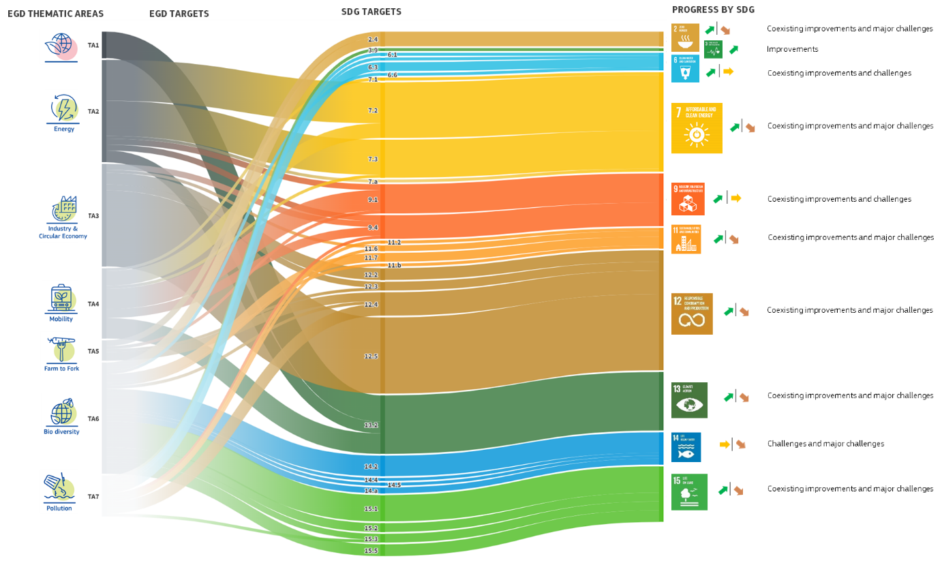Source: Authors’ elaboration, with flourish.studio.
Note: The thickness of the lines represents the number of EGD targets by thematic area and SDGs.

40The figure also highlights the relevance of achievement of EGD policy targets to boost the SDGs, both directly and indirectly through cascading effects(mention the parallel JRC report, as forthcoming). For instance, improvements on air quality objectives (Zero Pollution Action Plan and revised Ambient Air Quality Directive) bring positive contribution to the achievement of SDG 3 on health
In particular, the results of the 2025 assessment of progress towards EGD targets carried out by the JRC [40] can be looked through the “SDGs lens” to see where the two frameworks are mutually reinforcing/weakening (i.e. where and how EGD progress are affecting SDGs).

I WOULD REPLACE ALL THE TEXT BELOW WITH A TABLE for example like the one below...
We need to show how EGD boost SDGs (this is the title of the chapter), therefore, we should make clear which EGD policies/targets are boosting or weakening which SDGs ... Include ref. To ESTAT progress report and show if we are aligned with it and EUVR. The table below can be built with the results of the database.

The data show a mix of positive and negative contribution for SDG 2, in particular for target 2.4 on sustainable food production systems, thanks to the reduction in sales of antimicrobials for farmed animals and aquaculture, on track with the ambitions set in the ‘Farm to Fork Strategy’. On the negative side, the carbon stocks in EU agricultural soils have declined, with adverse consequences for the agricultural ecosystem.
The contribution of EGD ambition results positive for SDG 6, especially for granting access to sanitation and wastewater treatment (SDG 6.2), but challenging for improving water quality by reducing waste (6.3), especially for what regards the concentration of plastic litter at sea. The revision of the Urban Wastewater Treatment Directive aims to bring additional improvements not only for water quality, but also for access to sanitation.
Coexisting improvements and challenges occur as well in SDG 7, especially for what concerns the share of renewable energy in the global energy mix (SDG 7.2). Regarding energy efficiency (SDG 7.3) most of the EGD targets need acceleration. Positive outcomes will be visible when the set targets will reach a further level of implementation. .
For SDG 9 data shows existing challenges for what concerns the development of sustainable and resilient infrastructure (SDG 9.1), in particular for the installation of hydrogen electrolysers, as set in the REPowerEU Plan, the hydrogen refuelling stations mentioned in the Alternative Fuels Infrastructure Regulation, the deployment of recharging pools for light and heavy-duty vehicles, as recommended in the Sustainable and Smart Mobility strategy.
Positive trends and challenges coexist as well in the context of SDG 11 for sustainable cities and communities. As already indicated for SDG 3 on health, emissions of air pollutants have been reduced over recent decades, primarily as a result of the Ambient Air Quality Directives. The same for transport noise in cities and for residual (non-recycled) municipal waste, even if the improvements are still not sufficient to reach the targets set. Despite increasing recycling levels, the amount of waste generated is growing at a higher pace.
Existing improvements and challenges are observed for the SDG 12 on sustainable production and consumption. For natural resources (SDG 12.2), the EU extraction capacity of strategic raw materials has reached the target for some resources, but not for others. Regarding food waste (SDG 12.3) challenges still exist in the generation of food waste in processing and manufacturing, in retail and consumer levels. About the management of chemicals and waste (SDG 12.4), the data show a significant reduction in the use of chemical pesticides, but not enough for the more hazardous ones. Finally, many efforts are made to reduce waste generation through prevention, reduction, recycling and reuse (SDG 12.5). Almost half of the EGD related targets are on track to be achieved, especially for what concerns recycling efficiency of batteries, recovery of materials (with the exception of lithium), consumption of lightweight plastic carrier bags, recycle of materials contained in packaging waste, reuse and recycle of materials in vehicles.
The SDG 13 on climate action is crucial for many EGD targets and its overarching ambition of climate neutrality. Data show positive results especially for what concerns the EU Emission Trading System (ETS) and energy neutrality in the wastewater treatment sector. Other targets show positive progress, but data suggest that acceleration is needed for their achievement. This is the case for the overarching ambition of climate neutrality by 2050 and the interim climate target to reduce at least 55% GHG emissions, enshrined in the European Climate Law. The objective depends on the reduction of ESR sectors (transport, buildings, agriculture and waste), as well as on the EU net greenhouse gas removal in the LULUCF sector, that are not on track. Moreover, the ReFuelEU Aviation Regulation sets ambitious targets on Sustainable Aviation Fuel (SAF) made available to aircraft operators, but synthetic fuels are not available on the market yet, facing major technological and economic challenges.
Major challenges exist also for SDG 14 aimed at the conservation and sustainably use of seas and marine resources. Restoration measures are necessary to re-establish the habitat types in marine ecosystem (SDG 14.2), as indicated in the Nature Restoration Law. A positive trend is reported for the share of marine protected areas (SDG 14.5), even if acceleration is needed to achieve the targets set in the Biodiversity Strategy. Regarding the regulation of fishing practices (SDG 14.4), stock status has significantly improved but more efforts are needed to keep the fish stocks above MSY levels (Maximum Sustainable Yield), as pointed out in the Communication for the common fisheries policy today and tomorrow. Another critical aspect regards the scientific knowledge of the habitat condition in marine ecosystems (SDG 14.a), as well as terrestrial, coastal and freshwater ecosystem (SDG 15.1). Unfortunately, a significant percentage of their status remains unknown and more effective monitoring programs are needed.
Lastly, further challenges occur in SDG 15 for the protection, restoration and sustainable use of terrestrial ecosystems (SDG 15.1). The ambitions regarding biodiversity of forest ecosystem (SDG 15.2) still need a monitor system, but at least for the common forest bird index, data show a positive increasing trend. On the contrary, for what regards the restoration of land and soil (SDG 15.3), most of EU soils are not in healthy condition and soil erosion is expected to worsen due to climate change, and the target of ‘no net land take’, expected by the EU Soil Strategy for 2030, is still far to be reached. Other two alarm signals are the decrease of the common farmland bird index and the decline of pollinator populations, whose protection is crucial to halt the loss of biodiversity (SDG 15.5).

Delving deeper into the intricate interactions between the green transition and the SDGs, the data show how the achievement of specific EGD targets may trigger cascading effects across other SDGs, thereby amplifying progress in both frameworks.
In fact, the green transition has the potential to foster significant synergies across the targets, by addressing interconnected challenges. For instance, the Renewable Energy Directive targets a 32% share of renewable energy in the EU’s energy mix by 2030, which not only aligns with SDG targets for increasing renewable energy (SDG 7.2) but also supports climate action (SDG 13.2) and enhances public health by reducing air pollution (SDG 3.9). These renewable energy initiatives also contribute to job creation and economic growth (SDG 8.5), particularly in green technology sectors, thereby reinforcing the socio-economic objectives of the EGD. Similarly, the Farm to Fork Strategy, aiming to reduce pesticide use and increase organic farming, directly supports sustainable agriculture (SDG 2.4) and biodiversity (SDG 15.1), while also enhancing water management (SDG 6.4) and soil quality, which are critical for long-term food security (SDG 2.1).
Furthermore, the focus on sustainable infrastructure and industrial innovation, under policies such as the Industrial Strategy and the Circular Economy Action Plan, promotes resource efficiency (SDG 9.4) and waste reduction (SDG 12.5), while fostering technological advancements that benefit environmental and economic sustainability. Sustainable food production systems also play a pivotal role in improving ecosystem health, reducing pollution, and ensuring food security, thereby addressing multiple SDGs simultaneously. Additionally, water quality and ecosystem protection support not only environmental sustainability (SDG 6.3, 6.6, and 15.1) but also resilience against climate change impacts, contributing to broader goals of climate adaptation (SDG 13.1).
While the EGD may leverage synergies, it is crucial to acknowledge and manage the potential trade-offs that may arise, particularly when balancing diverse sustainability goals. For instance, the expansion of bioenergy production could lead to land-use conflicts, affecting food production (SDG 2.1) and biodiversity (SDG 15.1) by converting agricultural land to energy crops. Similarly, efforts to decarbonize industry through the development of renewable hydrogen, may increase water demand, potentially conflicting with sustainable water management goals (SDG 6.4). Additionally, the circular economy initiatives, while aimed at reducing waste, may result in energy-intensive recycling processes, potentially offsetting gains in energy efficiency (SDG 7.3) and complicating emissions reduction efforts (SDG 13.2). Moreover, the transition to a low-carbon economy, could disproportionately impact vulnerable populations, particularly through job losses in the fossil fuel sector and increased energy costs. This highlights the need for a fair and inclusive transition, as emphasized in the Just Transition Mechanism, to ensure that economic disparities are not exacerbated and that the most vulnerable are protected (see chapter 7, section on “Fair and Just Transition”). Similarly, the expansion of renewable energy infrastructure, such as offshore wind farms, poses risks to marine ecosystems (SDG 14.1), while land-based renewable projects may disturb natural habitats, leading to biodiversity loss (SDG 15.1).
Addressing these trade-offs requires coherent policy planning for the green transition, ensuring that advancements in one area do not come at the expense of sustainability in another. By integrating these considerations into policies, the EU can effectively navigate the complexities of sustainable development, supporting the simultaneous implementation of the SDGs and the green transition that needs to be fair and just, fostering competitiveness and security.

References
New political context and priorities
[1] E. Council, “EU Strategic Agenda 2024—2029.” [Online]. Available: https://www.consilium.europa.eu/media/yxrc05pz/sn02167en24_web.pdf
[2] M. Draghi, “The future of European competitiveness (Part A)—A competitiveness strategy for Europe.” European Commission. [Online]. Available: https://commission.europa.eu/document/download/97e481fd-2dc3-412d-be4c-f152a8232961_en?filename=The%20future%20of%20European%20competitiveness%20_%20A%20competitiveness%20strategy%20for%20Europe.pdf
[3] M. Draghi, “The future of European competitiveness (Part B) – In-depth analysis and recommendations.” European Commission. [Online]. Available: https://commission.europa.eu/document/download/ec1409c1-d4b4-4882-8bdd-3519f86bbb92_en?filename=The%20future%20of%20European%20competitiveness_%20In-depth%20analysis%20and%20recommendations_0.pdf
Cost of inaction - PESETA
Dottori F, Mentaschi L, Bianchi A et al. (2023). Cost-effective adaptation strategies to rising river flood risk in Europe. Nat. Clim. Chang. 13, 196–202. https://doi.org/10.1038/s41558-022-01540-0
European Commission (2024), Ninth report on economic, social and territorial cohesion. Publications Office of the European Union, Luxembourg.
Feyen L., Ciscar J.C., Gosling S., Ibarreta D., Soria A. (editors) (2020). Climate change impacts and adaptation in Europe. JRC PESETA IV final report. EUR 30180EN, Publications Office of the European Union, Luxembourg, ISBN 978-92-76-18123-1, doi:10.2760/171121, JRC119178.
García-León D, Masselot P, Mistry MN, Gasparrini A, Motta C, Feyen L, Ciscar JC (2024), Temperature-related mortality burden and projected change in 1368 European regions: a modelling study. Lancet Public Health Sep;9(9):e644-e653. doi: 10.1016/S2468-2667(24)00179-8.
Matei NA, García-León D, Dosio A et al. (2023). Regional impact of climate change on European tourism demand, Publications Office of the European Union, Luxembourg, doi:10.2760/899611, JRC131508.
Naumann G., Cammalleri C., Mentaschi L., Feyen L (2021). Increased economic drought impacts in Europe with anthropogenic warming. Nature Climate Change 11: 485–491.
Vousdoukas MI, Mentaschi L, Hinkel J et al. (2020). Economic motivation for raising coastal flood defenses in Europe. Nat Commun 11, 2119. https://doi.org/10.1038/s41467-020-15665-3
Wojciech Szewczyk et al (2021) Environ. Res. Lett. 16 105002, DOI 10.1088/1748-9326/ac24cf

Introduction (ex chapter 1)
[1] E. Council, “EU Strategic Agenda 2024—2029.” [Online]. Available: https://www.consilium.europa.eu/media/yxrc05pz/sn02167en24_web.pdf
[2] M. Draghi, “The future of European competitiveness (Part A)—A competitiveness strategy for Europe.” European Commission. [Online]. Available: https://commission.europa.eu/document/download/97e481fd-2dc3-412d-be4c-f152a8232961_en?filename=The%20future%20of%20European%20competitiveness%20_%20A%20competitiveness%20strategy%20for%20Europe.pdf
[3] M. Draghi, “The future of European competitiveness (Part B) – In-depth analysis and recommendations.” European Commission. [Online]. Available: https://commission.europa.eu/document/download/ec1409c1-d4b4-4882-8bdd-3519f86bbb92_en?filename=The%20future%20of%20European%20competitiveness_%20In-depth%20analysis%20and%20recommendations_0.pdf
[4] U. von der Leyen, “EUROPE’S CHOICE POLITICAL GUIDELINES FOR THE NEXT EUROPEAN COMMISSION 2024−2029.” European Commission. [Online]. Available: https://commission.europa.eu/document/download/e6cd4328-673c-4e7a-8683-f63ffb2cf648_en?filename=Political%20Guidelines%202024-2029_EN.pdf

[1] E. Council, ‘EU Strategic Agenda 2024—2029’. [Online]. Available: https://www.consilium.europa.eu/media/yxrc05pz/sn02167en24_web.pdf
[2] M. Draghi, ‘The future of European competitiveness (Part A)—A competitiveness strategy for Europe’. European Commission, Sep. 2024. [Online]. Available: https://commission.europa.eu/document/download/97e481fd-2dc3-412d-be4c-f152a8232961_en?filename=The%20future%20of%20European%20competitiveness%20_%20A%20competitiveness%20strategy%20for%20Europe.pdf
[3] M. Draghi, ‘The future of European competitiveness (Part B) – In-depth analysis and recommendations’. European Commission, Sep. 2024. [Online]. Available: https://commission.europa.eu/document/download/ec1409c1-d4b4-4882-8bdd-3519f86bbb92_en?filename=The%20future%20of%20European%20competitiveness_%20In-depth%20analysis%20and%20recommendations_0.pdf
[4] Directorate-General for Communication (European Commission) and U. von der Leyen, Europe’s choice: political guidelines for the next European Commission 2024−2029. Publications Office of the European Union, 2024. Accessed: Mar. 19, 2025. [Online]. Available: https://data.europa.eu/doi/10.2775/260104
[5] T. M. Lenton et al., ‘Global Tipping Points’, University of Exeter, Exeter, UK, 2023. Accessed: Mar. 27, 2025. [Online]. Available: https://report-2023.global-tipping-points.org
[6] T. M. Lenton et al., ‘Using GENIE to study a tipping point in the climate system’, Phil. Trans. R. Soc. A., vol. 367, no. 1890, pp. 871–884, Mar. 2009, doi: 10.1098/rsta.2008.0171.
[7] D. I. Armstrong McKay et al., ‘Exceeding 1.5°C global warming could trigger multiple climate tipping points’, Science, vol. 377, no. 6611, p. eabn7950, Sep. 2022, doi: 10.1126/science.abn7950.
[8] T. Powell, S. R. Smith, C. Zimm, and E. Bailey, ‘4: Positive tipping points in technology, economy and society’, University of Exeter Design, 2023. Accessed: Mar. 27, 2025. [Online]. Available: https://report-2023.global-tipping-points.org
[9] ‘PESETA climate change projects - European Commission’. Accessed: Mar. 27, 2025. [Online]. Available: https://joint-research-centre.ec.europa.eu/scientific-activities/peseta-climate-change-projects_en
[10] European Commission. Joint Research Centre., Analysis of climate change impacts on EU agriculture by 2050: JRC PESETA IV project : Task 3. LU: Publications Office, 2020. Accessed: Oct. 30, 2024. [Online]. Available: https://data.europa.eu/doi/10.2760/121115
[11] European Commission. Joint Research Centre., Climate change impacts and adaptation in Europe: JRC PESETA IV final report. LU: Publications Office, 2020. Accessed: Oct. 30, 2024. [Online]. Available: https://data.europa.eu/doi/10.2760/171121
[12] V. Cuming and H. Bromley, ‘Biodiversity Finance Factbook’, BloombergNEF, Apr. 2023. [Online]. Available: https://assets.bbhub.io/professional/sites/24/REPORT_Biodiversity_Finance_Factbook_master_230321.pdf
[13] ‘$1 Trillion to Protect Biodiversity is Cheaper Than the Cost of Inaction’, BloombergNEF. Accessed: Mar. 27, 2025. [Online]. Available: https://about.bnef.com/blog/1-trillion-to-protect-biodiversity-is-cheaper-than-the-cost-of-inaction/
[14] T. Roxburgh et al., ‘Global Futures: Assessing the global economic impacts of environmental change to support policy-making. Summary report’, WWF UK, Jan. 2020. [Online]. Available: https://www.wwf.org.uk/sites/default/files/2020-02/GlobalFutures_SummaryReport.pdf
[15] EPIC, ‘Biodiversity: The costs of inaction’, Friends of Europe. Accessed: Mar. 27, 2025. [Online]. Available: https://www.friendsofeurope.org/insights/biodiversity-the-costs-of-inaction/
[16] ‘Welcome to INCA | INCA Platform’. Accessed: Mar. 27, 2025. [Online]. Available: https://ecosystem-accounts.jrc.ec.europa.eu/
[17] WEF, ‘Quantifying the Impact of Climate Change on Human Health’, World Economic Forum, Jan. 2024. Accessed: Mar. 27, 2025. [Online]. Available: https://www.weforum.org/publications/quantifying-the-impact-of-climate-change-on-human-health/
[18] WEF, ‘Health and climate change’, World Economic Forum, Jun. 2024. Accessed: Mar. 27, 2025. [Online]. Available: https://www.weforum.org/publications/health-impacts-of-climate-change-the-role-of-the-private-sector/
[19] European Environment Agency, Ed., Climate change as a threat to health and well-being in Europe: focus on heat and infectious diseases. in EEA report, no. no. 2022, 07. Luxembourg: Publications Office of the European Union, 2022. doi: 10.2800/67519.
[20] J. Ballester et al., ‘Heat-related mortality in Europe during the summer of 2022’, Nat Med, vol. 29, no. 7, pp. 1857–1866, Jul. 2023, doi: 10.1038/s41591-023-02419-z.
[21] G. D’Amato, L. Cecchi, M. D’Amato, and I. Annesi-Maesano, ‘Climate change and respiratory diseases’, Eur Respir Rev, vol. 23, no. 132, pp. 161–169, Jun. 2014, doi: 10.1183/09059180.00001714.
[22] N. Watts et al., ‘The 2020 report of The Lancet Countdown on health and climate change: responding to converging crises’, The Lancet, vol. 397, no. 10269, pp. 129–170, Jan. 2021, doi: 10.1016/S0140-6736(20)32290-X.
[23] ‘Air pollution in the EU: facts and figures’, Consilium. Accessed: Mar. 27, 2025. [Online]. Available: https://www.consilium.europa.eu/en/infographics/air-pollution-in-the-eu/
[24] K. N. Domingo et al., ‘Impact of climate change on paediatric respiratory health: pollutants and aeroallergens’, Eur Respir Rev, vol. 33, no. 172, p. 230249, Apr. 2024, doi: 10.1183/16000617.0249-2023.
[25] I. R. Lake et al., ‘Climate Change and Future Pollen Allergy in Europe’, Environ Health Perspect, vol. 125, no. 3, pp. 385–391, Mar. 2017, doi: 10.1289/EHP173.
[26] M. Romanello et al., ‘The 2023 report of the Lancet Countdown on health and climate change: the imperative for a health-centred response in a world facing irreversible harms’, The Lancet, vol. 402, no. 10419, pp. 2346–2394, Dec. 2023, doi: 10.1016/S0140-6736(23)01859-7.
[27] ‘Worsening spread of mosquito-borne disease outbreaks in EU/EEA, according to latest ECDC figures’. Accessed: Mar. 27, 2025. [Online]. Available: https://www.ecdc.europa.eu/en/news-events/worsening-spread-mosquito-borne-disease-outbreaks-eueea-according-latest-ecdc-figures
[28] S. J. Ryan, C. J. Carlson, E. A. Mordecai, and L. R. Johnson, ‘Global expansion and redistribution of Aedes-borne virus transmission risk with climate change’, PLoS Negl Trop Dis, vol. 13, no. 3, p. e0007213, Mar. 2019, doi: 10.1371/journal.pntd.0007213.
[29] I. A. Lambraki et al., ‘Governing Antimicrobial Resistance (AMR) in a Changing Climate: A Participatory Scenario Planning Approach Applied to Sweden in 2050’, Front. Public Health, vol. 10, p. 831097, Jul. 2022, doi: 10.3389/fpubh.2022.831097.
[30] A. Meinen, S. Tomczyk, F. N. Wiegand, M. Abu Sin, T. Eckmanns, and S. Haller, ‘Antimicrobial resistance in Germany and Europe – A systematic review on the increasing threat accelerated by climate change’, Jun. 2023, doi: 10.25646/11404.
[31] ‘What is fuelling the world’s antimicrobial resistance crisis?’ Accessed: Mar. 27, 2025. [Online]. Available: https://www.unep.org/news-and-stories/story/what-fuelling-worlds-antimicrobial-resistance-crisis
[32] R. Magnano San Lio, G. Favara, A. Maugeri, M. Barchitta, and A. Agodi, ‘How Antimicrobial Resistance Is Linked to Climate Change: An Overview of Two Intertwined Global Challenges’, IJERPH, vol. 20, no. 3, p. 1681, Jan. 2023, doi: 10.3390/ijerph20031681.
[33] H. E. J. Kaba, E. Kuhlmann, and S. Scheithauer, ‘Thinking outside the box: Association of antimicrobial resistance with climate warming in Europe – A 30 country observational study’, International Journal of Hygiene and Environmental Health, vol. 223, no. 1, pp. 151–158, Jan. 2020, doi: 10.1016/j.ijheh.2019.09.008.
[34] P. Kumar, L. Brander, M. Kumar, and P. Cuijpers, ‘Planetary Health and Mental Health Nexus: Benefit of Environmental Management’, agh, vol. 89, no. 1, p. 49, Jul. 2023, doi: 10.5334/aogh.4079.
[35] J. Liu et al., ‘Is there an association between hot weather and poor mental health outcomes? A systematic review and meta-analysis’, Environment International, vol. 153, p. 106533, Aug. 2021, doi: 10.1016/j.envint.2021.106533.
[36] L. Brandt et al., ‘Climate change and mental health: Position paper of the European Psychiatric Association’, Eur. Psychiatr., vol. 67, no. 1, p. e41, 2024, doi: 10.1192/j.eurpsy.2024.1754.
[37] M. F. H. Artiles, ‘The cascading effects of the Valencia floods: how public health faces the challenges of the disaster’, SMC España. Accessed: Mar. 27, 2025. [Online]. Available: https://sciencemediacentre.es/en/cascading-effects-valencia-floods-how-public-health-faces-challenges-disaster
[38] K. Jeevan Jyoti, K. Atul, and T. Manjusha, ‘Permafrost Thawing: A New Potential Risk for the Human Health’, Applied Ecology and Environmental Sciences, vol. 11, no. 2, pp. 54–55, May 2023, doi: 10.12691/aees-11-2-2.
[39] R. Wu, G. Trubl, N. Taş, and J. K. Jansson, ‘Permafrost as a potential pathogen reservoir’, One Earth, vol. 5, no. 4, pp. 351–360, Apr. 2022, doi: 10.1016/j.oneear.2022.03.010.
[40] L. Marelli et al., ‘Delivering the EU Green Deal - Progress towards targets’, European Commission: Joint Research Centre, Luxembourg, JRC140372, Jan. 2025. doi: 10.2760/3105205.
[41] European Commission, ‘Delivering on the UN’s Sustainable Development Goals – A comprehensive approach’. Nov. 18, 2020. [Online]. Available: https://data.consilium.europa.eu/doc/document/ST-13120-2020-INIT/en/pdf
[42] United Nations, ‘The Sustainable Development Goals Report 2024’. Accessed: Mar. 27, 2025. [Online]. Available: https://unstats.un.org/sdgs/report/2024/
[43] European Commission. Statistical Office of the European Union., Sustainable development in the European Union: monitoring report on progress towards the SDGs in an EU context : 2024 edition. LU: Publications Office, 2024. Accessed: Mar. 27, 2025. [Online]. Available: https://data.europa.eu/doi/10.2785/98370
[44] G. Lafortune, L. Fuller, A. Kloke-Lesch, P. Koundouri, and A. Riccaboni, ‘European Elections, Europe’s Future and the Sustainable Development Goals. Europe Sustainable Development Report 2023/24’, SDSN and SDSN Europe. Paris: SDSN, Dublin: Dublin University Press, 2024. doi: 10.25546/104407.

Annex.

The study explores potential differences in sentiments between EU-affiliated accounts, from EU institutions or officials (including Members of the European Parliament (MEPs) and those from the broader public. It is important to note that, while tweets from EU-affiliated accounts might provide valuable insights, they do not necessarily represent official EU communications.

